FAQS
Q. What, When & Where is the Komen Greater St. Louis MORE THAN PINK Walk?
A. The 2 mile communal walk is a way to show breast cancer survivors and thrivers that we support them and to celebrate our fundraising efforts. The excitement will be downtown near Soldiers Memorial; here is a schedule of events:
Saturday, June 8, 2019
7:30 am festivities start
9:00 am opening ceremony
9:30 am 2 mile walk starts
10:00 am celebration continues, music & fun!
Q. How much is the registration fee & how do I register?
A. Registration is $25 per participant, adult, youth and virtual walkers. Best way to register is to go to www.komenmissouri.org/stlwalk, you can also register in person, dates and times below.
You can also register offline by downloading a mail-in registration form and mailing to the address below with payment:
Susan G. Komen Missouri
PO BOX 790129 DEPT. SK
St. Louis, MO 63179-0129
Q. What are things I should know about the MORE THAN PINK Walk?
A. You should know Komen Missouri’s mission to find the cures for breast cancer has not changed. The Walk is our largest signature and fundraising event and exciting changes are taking place. You will see more color, pink will be there for sure, it’s our calling card, but look for purple, blue, green and orange which represent the four pillars of our organization, research, community, care and action. There will be activities in tents to help you understand what these mean. You will also see a We Remember tent; this will be a place of reverence to remember those we have lost to this disease. Bring a picture of your loved one to hang inside and share their story with others.

The Walk day itself is a way for us to celebrate our fundraising efforts. Yes, we are asking participants to collect donations, which are the reason we can fund community programs like free mammograms and ground breaking research. In order to direct as much funding as possible to our mission only Survivors and participants who raise $100 or more above their registration fee will receive a commemorative Walk t-shirt. Yep, big change, but ensures money supports the our purpose.
Q. If I’m a survivor or raise $100 or what to register in person, where do I go?
A. See below for survivor and fundraising t-shirt pick-up and in person registration times and locations.
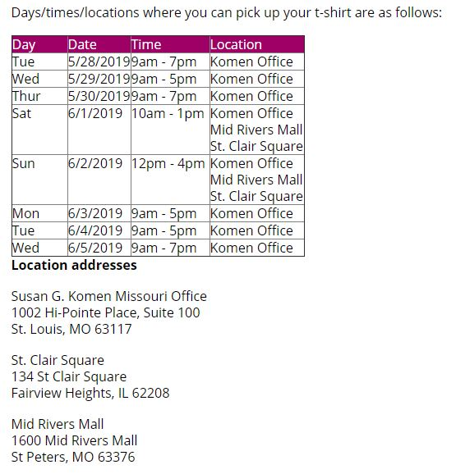

Q. Will there still be a Sponsors' Row?
A. Yes, sponsors will be on site so that participants can engage with our valued partners and sponsors who help make our Walk possible. Please note, sponsors will pause activities, handing out items, talking with participants, etc. at 9 a.m. so everyone can take part in our opening ceremony at the main stage.
Q. How is the money used? Why is fundraising important?
A. Your fundraising will help us do more for research, more for our communities, more for caring for those living with breast cancer – including metastatic breast cancer – and more action to get us to a cure. Thanks to the funds you raise, Komen Missouri is funding cutting-edge breast cancer research and working to support people in our communities. Komen works every day to:
  - Better detect, prevent and treat all breast cancers, especially deadly metastatic breast cancer
  - Increase access to and participation in innovative clinical trials
  - Improve access to quality breast health services by funding essential patient navigator
  - Provide underserved patients with low- or no-cost screening, diagnosis and treatment
  - Eliminate barriers to care by supporting life-changing services like transportation, medication access and child care
  - Eliminate disparities in breast cancer care and outcomes by assessing gaps in access and quality
  - Provide accurate and balanced information, support and compassion through the Komen Breast Care Helpline
  - Advocate for federal research funding and access to affordable, high-quality breast health and cancer care services
Provide the public and our elected officials with factual, evidence-based breast cancer information
Q. How can I become a volunteer?
A. The success of the Komen Greater St. Louis MORE THAN PINK Walk depends heavily on the support received from volunteers in the months leading up to event day. There are many ways you can get involved. Click here for our volunteer page.

For additional information and expanded FAQ please go to www.komenmissouri.org/STLwalk.

